Mocharla Ruthvik Sai

**ASSIGNMENT_1**

**1. Write the Algorithm and draw the flowcharts for the following:**

**a) Find the average of three numbers a, b and c**

A) Algorithm:

Step 1: Start.

Step 2: Read the three numbers a, b, c

Step 3: sum = a+b+c

Step 4: avg = sum/3

Step 5: Display "sum" and "avg".

Step 6: End

Flowchart:

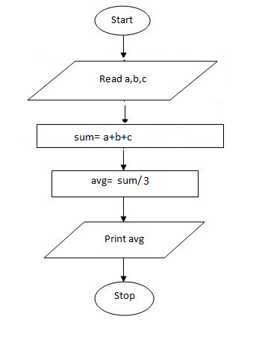

b) Find the area of a rectangle whose length and breadth are given.

A) Algorithm:

Step 1: Start

Step 2: Read “Length” and “Breadth”

Step 3: Area = Length*Breadth

Step 4: Display “Area”

Step 5: End

Flowchart:

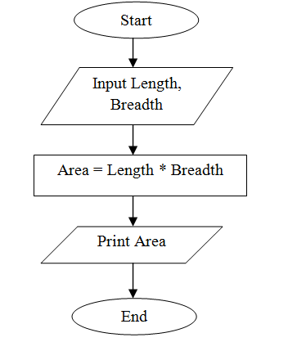

2. Draw the flowcharts for the following:

a) Read age of a person. If age less than 60 then print “Not a senior citizen”. Otherwise print “Senior Citizen”.

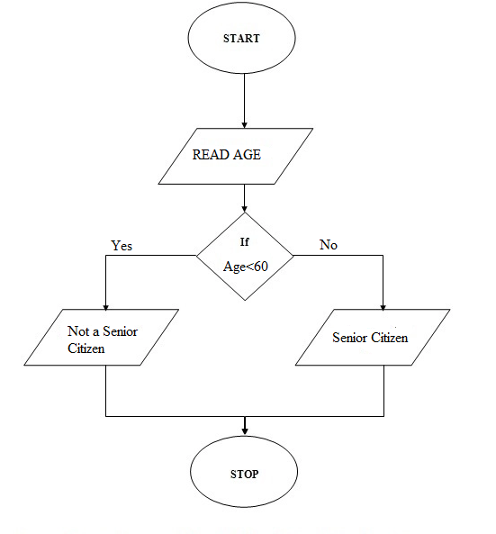

b) Read two numbers and print maximum of 2 numbers.

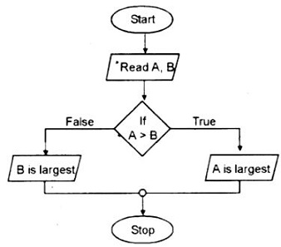

c) Read three numbers and print smallest among 3 numbers

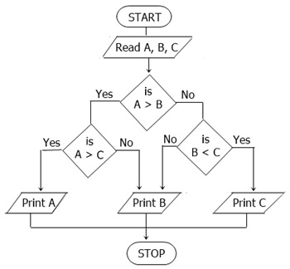

d) Read a number in inches and convert it into meters

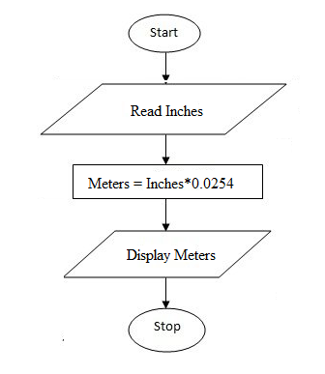

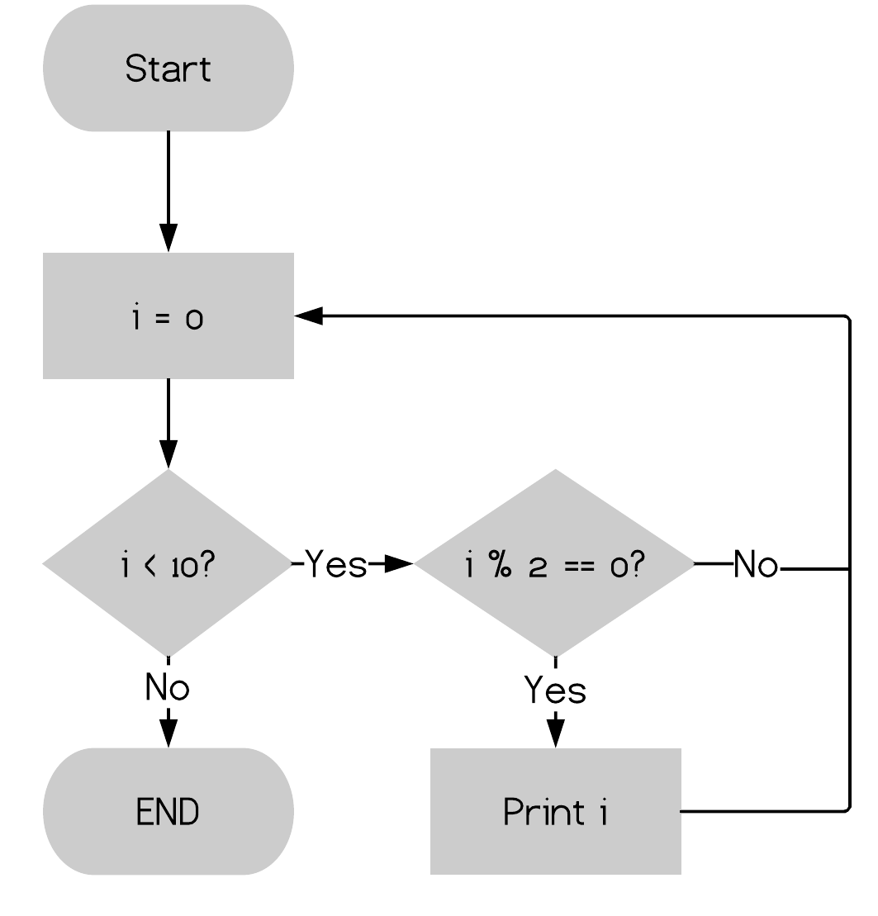e) Print 2, 4, 6, 8, 10